**Module-6 (Bootstrap)**

**Q1:** **What are the advantages of Bootstrap?**

**Ans:** Bootstrap is a popular front-end framework for creating responsive websites.

**The Advantages of Bootstrap Is Given Below**

1. **Responsive Design**
2. **Time Saving**
3. **Customizable and Theming**
4. **Support Flex-box and grid**
5. **Well maintained and updated**
6. **Compatibility with other libraries**
7. **Responsive Design:** One of the biggest advantage of bootstrap is its provide built-in responsive grid system. It allows developers to create websites that automatically adapt to different screen sizes and devices.
8. **Time saving:** Bootstrap comes with a pre-designed CSS styles, component and JavaScript plugins that can be readily used to build common UI elements like buttons, forms, modals, nav bar etc.
9. **Customizable and Theming:** Bootstrap is highly customizable. Developers can easily customize the look and feel of the framework to match their projects specific design requirements.
10. **Support flex-box and Grid:** The modern CSS features like flex-box and grid. Bootstrap supports flex-box and grid for layout system. Making is easier to create complex and flexible layout.
11. **Well maintained and updated:** Bootstrap is actively maintained by team of developers ensuring that it stay up-to-date with the latest web standards and best practices.
12. **Compatibility with other libraries:** Bootstrap can be easily integrated with other JavaScript libraries and frame works, such as jQuery, making it versatile and adaptable to different project requirements.

**Q2:** What is a Bootstrap Container, and how does it work?

**Ans:** In Bootstrap container is used to create a responsive grid system.

**There are two types of containers in bootstrap**

1. **Container**
2. **Container-Fluid**

**1.Container:** This is the standard container class that provides a responsive fixed-width container. It adjusts its width based on screen size. It has a predefined maximum width, and the content inside it will be centered horizontally.

**2.Container-Fluid:** This class create a full-width container that spans the entire width of the viewport.it does not have a fix width and expands to fill the available space.

**How the bootstrap container works**

**1.Responsive grid:** When you placed element inside container, you can use Bootstrap’s grid classes to create responsive colum and rows.

**2.Centered content:** The standard container class (.container) centers the content inside it horizontally.

**3.Padding and Margin:** Bootstrap containers apply appropriate padding and margin to the content inside them, helping to create consistent spacing between elements.

**Example to create bootstrap container in html.**

<div class=”container”>

<div class=” row”>

<div class=”col-6”>

**Q3:** **Semantic element in HTML5?**

**Ans:** Semantic elements in html-5 are tags that provide meaning and structure to the content of a web page.

Here some semantic elements given below:

**1.<header>:** Represent header content of a web page.

**2.<nav>:** Defines a section of navigation links.

**3.<main>:**  Represent the main content of the document.

**4.<section>:** Define stand alone section with related content.

**5.<time>:** Specifies a specific time

**6.<figure>:** Represents self-contained content, such as an image, screen shot etc.

**7.<figure caption>:** Provide a caption or description for given content in <figure>.

**Example:** 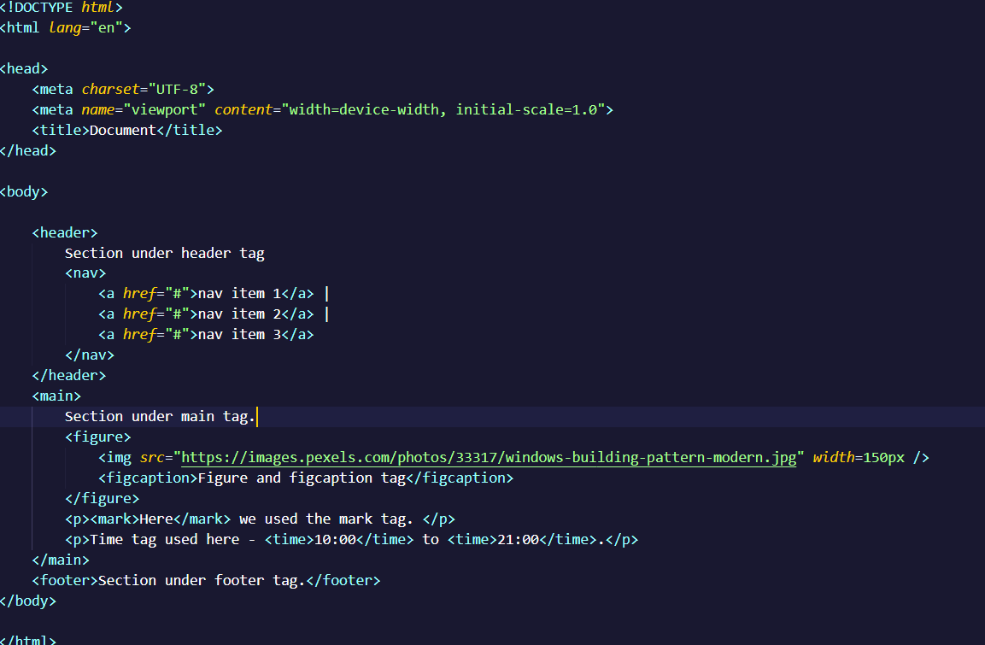

**Output:**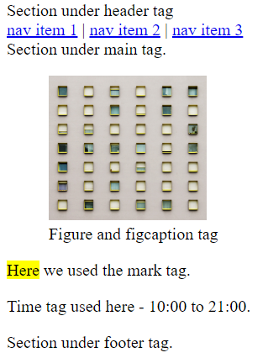

**Q4:** **Canvas and SVG tags**

**Ans: SVG:** SVG stands for scalable vector graphics. SVG image are resolution-independent and can be scaled without losing image quality.

The <svg> tag is an xml-based vector graphics format that allows for creation scalable 2D vector graphics. It uses XML syntax to define paths, and other graphical elements.

**Example:**

<svg width="500" height="300">

<rect x="0" y="0" width="200" height="200" fill="red"></rect>

</svg>

**Canvas:** The canvas tag is used to draw graphics, on the fly via java script. The canvas tag is transparent, and is only for container graphics, you must use a script to actually draw the graphics.

**Example:**

<canvas> This is a canvas tag </canvas>